**Seeeduino-V4.2 firmware burning Guide**

**Preparation:**

1. We can follow the instructions below to burn the firmware of the interface and mcu into a completely normal seeeduino v4.2 (or other arduino main control board) via the USB port.
2. And then use this Seeeduino as an offline burner, to burn the firmware into those abnormal boards.

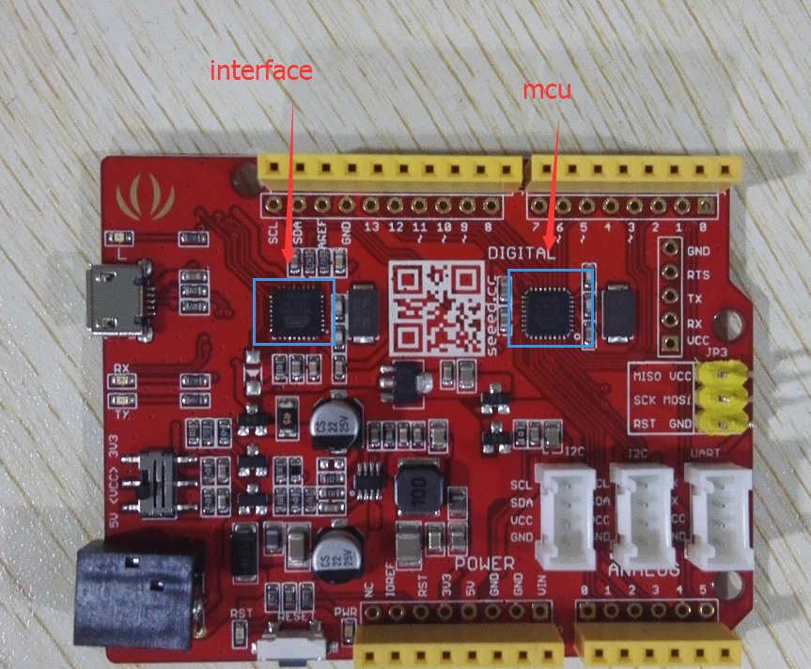

1. Take six jumpers, connect three of them to the **MISO**, **MOSI**, **SCK** of the burner. Connect another jumper to **D6** pin of the burner. The jumper connected to **D6** will provide Reset signal for the chip which needs to be burned. Then attach the rest jumper to **VCC** and **GND.**

**Burn the firmware:**

**For** **Mcu(Atmega328P)**

1. Connect the burner to your PC, then open the software **xloader** to burn the file **seeeduino_v4_mcu_boot.ino.hex** to the burner. Select the corresponding device (If you are using **seeeduino v4.2**, please select **uno**) and COM port. Then click **upload**(click once will be ok).

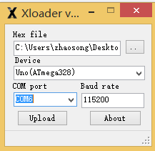

1. Connect the six jumpers from the burner to the **SPI** interface of the MCU which needs to be burned.

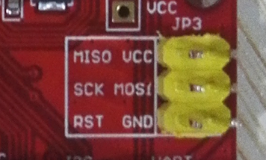

|  |  |
| --- | --- |
| Burner | Chip to be burned |
| MOSI | MOSI |
| MISO | MISO |
| SCK | SCK |
| D6 | RST |
| VCC | VCC |
| GND | GND |

1. Open the serial port tool **SScom32**, set the baud rate at 115200, and select the corresponding serial port of the burner.

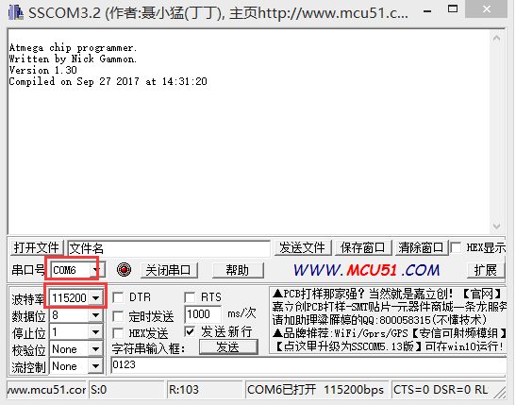

1. Send any character to the burner, the burning will start automatically.

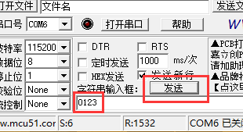

1. When the burning finished, the program will continue to print **“PROGRAM OVER”**.Please check whether there is an error while burning, if there is, you can simply fix it by reset the burner.

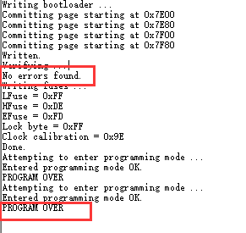

**For Interface(Atmega16U2)**

1. Use xloader to burn the file **seeeduino_v4_interface_boot.ino.hex** to the burner, select the corresponding device (If you are using seeeduino v4, please select uno) and COM port. Then click upload (click once will be ok).
2. Refer to the steps 2，3，4，5 of the MCU, please pay attention to the port order. 